**Figure 1.** (a) A map of all sites sampled during 2018 and 2019. Sites from the Wright et al. study (Wright *et al.*, 2019) conducted in 2016 are also included. The color and shape of each point corresponds to the year the site was sampled. (b) A species range polygon for the yellow-naped amazon provided by BirdLife (BirdLife International and Handbook of the Birds of the World, 2019).

**Figure 2**. Spectrograms of each identified call variant with the country of origin listed above and the call variant name listed below the image. All images are shown on a 0.6 second timescale at 3.5 kHz frequency.

**Figure 3.** An image using spectrograms to depict the common ways in which yellow-naped amazon contact calls can structurally vary.

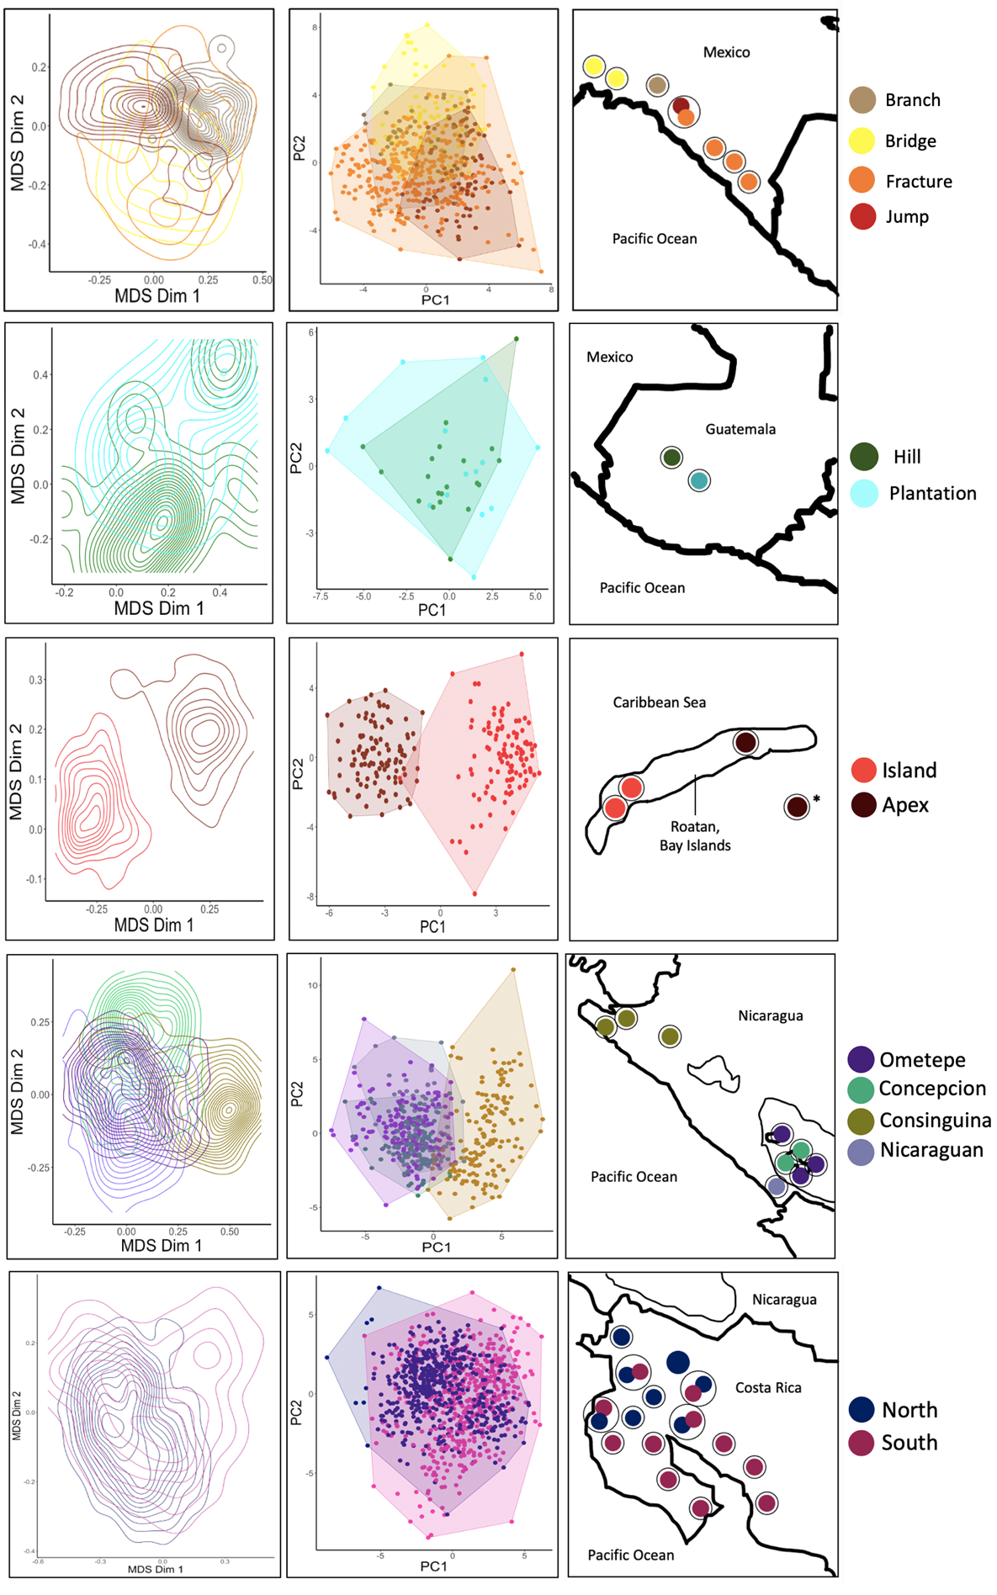

A

B

C

D

Mexico

Nicaragua

Honduras

Guatemala

Costa Rica

**Figure 4.** A multi-panel image with four columns showing SPCC plots (A), PCA plots (B), a geographic map (C), and a legend (D), in that order. Rows represent the sampled countries, arranged in order from north to south. The geographic map for Honduras depicts the call type for the undisclosed location using an asterisk (*). Black circles represent a single site.